**IOT BASED SMART WATER HEATER**

**MINI PROJECT REPORT**

***Submitted By***

**RAM PRAKASH L 2116210701208**

**RAVEENA SRI R 2116210701210**

***in partial fulfilment for the award of the degree***

***of***

**BACHELOR OF ENGINEERING**

***in***

**COMPUTER SCIENCE AND ENGINEERING**

** **

**RAJALAKSHMI ENGINEERING COLLEGE DEPARTMENT OF COMPUTER ENGINEERING ANNA UNIVERSITY, CHENNAI**

**MAY 2024**

**RAJALAKSHMI ENGINEERING COLLEGE CHENNAI**

**BONAFIDE CERTIFICATE**

Certified that this Report titled “**IOT BASED SMART WATER HEATER**” is the bonafide work of **RAM PRAKASH L (210701208),RAVEENA SRI R (210701210)** who carried out the work under my supervision. Certified further that to the best of my knowledge the work reported herein does not form part of any other thesis or dissertation on the basis of which a degree or award was conferred on an earlier occasion on this or any other candidate.

## SIGNATURE

MRS. ANITHA ASHIDEEP , M.TECH

## PROJECT COORDINATOR

Assistant Professor

Department of Computer Science and Engineering Rajalakshmi Engineering College

Chennai - 602 105

Submitted to Project Viva-Voce Examination held on

**Internal Examiner External Examiner**

**ABSTRACT**

This project aims to create a project based on The Internet of Things (IoT) which is used by humans to interact with everyday appliances, which offers enhanced control and efficiency. We propose an IoT-based smart water heater control system for optimizing energy usage and to help the user in their convenience.The system consists of a microcontroller, sensors, actuators, and a user interface accessed by mobile application or website. Temperature and humidity sensors used to monitor environmental conditions and changes are made according to them. These data are transmitted to the microcontroller which is a mini computer,used to integrate the embedded systems and optimize water heating schedules accordingly.Through the mobile application or web portal, users can control the water heater without manual mode, and by adjusting the temperature, scheduling the heating cycles, and can receive real-time status updates. Machine learning algorithms may be used inorder to learn more about user preferences over time and further optimization of energy usage.The benefits of this project includes energy conservation, cost savings, and improving the user experience. By using various IoT technologies, this project demonstrates the capability of controlling the systems to enhance the efficiency and provide the user with better usability of household appliances like water heaters.

**ACKNOWLEDGMENT**

Initially we thank the Almighty for being with us through every walk of our life and showering his blessings through the endeavor to put forth this report. Our sincere thanks to our Chairman **Mr. S.MEGANATHAN, B.E, F.I.E.**, our Vice Chairman **Mr. ABHAY SHANKAR MEGANATHAN, B.E., M.S.,** and our respected Chairperson **Dr. (Mrs.) THANGAM MEGANATHAN**, **Ph.D.,** for providing us with the requisite infrastructure and sincere endeavoring in educating us in their premier institution.

Our sincere thanks to **Dr. S.N. MURUGESAN, M.E., Ph.D.,** our beloved Principal for his kind support and facilities provided to complete our work in time. We express our sincere thanks to **Dr.P.KUMAR, Ph.D.**, Professor and Head of the Department of Computer Science and Engineering for his guidance and encouragement throughout the project work. We convey our sincere and deepest gratitude to our internal guide, **Mrs. ANITHA ASHIDEEP, M.TECH,** Department of Computer Science and Engineering, Rajalakshmi Engineering College for his valuable guidance throughout the course of the project.

**RAM PRAKASH L 2116210701208**

**RAVEENA SRI R 2116210701210**

**TABLE OF CONTENTS**

| **CHAPTER NO** | **TITLE** | **PAGE NO** |
| --- | --- | --- |
| **1** | **INTRODUCTION** | 1 |
| **2** | **LITERATURE SURVEY** | 2 |
| 2.1 | EXISTING SYSTEM | 3 |
| **3** | **PROJECT DESCRIPTION** | 4 |
| 3.1 | PROPOSED SYSTEM | 6 |
| 3.2 | REQUIREMENTS | 6 |
| 3.2.1 | HARDWARE REQUIREMENTS | 6 |
| 3.2.2 | SOFTWARE REQUIREMENTS | 6 |
| 3.3 | ARCHITECTURE DIAGRAM | 7 |
| 3.4 | OUTPUT | 8 |
| **4** | **CONCLUSION AND FUTURE WORK** | 11 |
|  | **APPENDICES** | 12 |
|  | **REFERENCE** | 14 |

**CHAPTER 1**

**INTRODUCTION**

In this modern era we have various technologies to make our day easier, one such thing is integrating, internet of things in our daily activity for ensuring efficient delivery and accessibility. With the advancement of technology, the Internet of Things (IoT) is emerging as a platform which makes human work easier,by revolutionizing various aspects of our daily lives. One area which made IoT a great success is home automation, where smart devices can enhance convenience, efficiency, and control. Here, in our project we focus on developing an IoT-based control system for water heaters, aimed at optimizing energy consumption and improving user experience. Traditional water heaters operate on fixed schedules or require manual controls, often resulting in energy wastage and inconvenience for users. However, by integrating IoT with water heater systems, by introducing these intelligent features we can adapt to user preferences and environmental conditions.

Oue core idea of this project is to use IoT technologies to create a smart water heater which offers remote access, automated scheduling, and energy-efficient operation. By connecting the sensors, actuators, and connectivity features,we can monitor our system and adjust water heating processes in real-time, based on the factors such as ambient temperature, and user preferences. We can also access the mobile applications or web portals which are user-friendly, users can remotely monitor and control their water heaters. They can set desired temperature levels, schedule heating cycles according to their daily routines, and we receive notifications about system status by which we can modify the system and energy consumption.

The main benefits of our IoT-based water heater control system have different parts,forms and features. Firstly, it provides many benefits to the users to optimize energy usage, thereby reducing utility bills and environmental impact. Secondly, it provides convenience by allowing remote control and monitoring, enabling users to have hot water according to their needs. Lastly, by incorporating data analytics and machine learning algorithms, the system can learn continuously and adapt to user behavior, further improving the efficiency and providing user satisfaction over time. In summary, our project aims to showcase the idea which provides an automated environment of IoT technology in the realm of household appliances, specifically water heaters. By creating a smart, connected system, we create a future where energy-efficient and user-friendly solutions become the norm, ultimately contributing to sustainability and enhanced quality of life.

**CHAPTER 2**

**LITERATURE SURVEY**

(Chandrasekaran, Gokul, et al) This project proposes a smart solar water heater system that uses Internet of Things (IoT) technology to monitor and control water temperature, tank levels, and water quality. By adding sensors and internet connectivity to the water heater, users can adjust settings remotely via their smartphones or computers and also not only enhances efficiency but also offers convenience for users, making it suitable for both smart homes and industrial applications.

(Chandla ellis, et.al., 2022)This research mainly discusses how solar water heating systems in homes have become more energy efficient with the help of Internet of Things (IoT) technology, which are used to collect various data about the system, which is then used to identify ways to improve different parts of the system.

(Cardona, et.al., 2019)This project mainly addresses the need for an electronic tool to monitor water temperature over time, as solar water heaters become more popular in households and This proposed solution is a wireless temperature monitoring system for domestic water heater tanks, designed to be user-friendly and cost-effective for widespread adoption.

(Khairunnas, Muhammad Dio, et.al., 2018)This system introduces an automatic faucet designed to simplify the process of filling a bathtub with hot water. Traditional water heaters can be slow to reach the desired temperature and fill the tub, so this system aims to speed up the process.

(Susanti, Hera, et al., 2023) This project incorporates temperature and water flow sensors, with data processed through a NodeMCU microcontroller and transmitted to Firebase for display on the application interface. Users can set desired water quantities and temperatures, with the application managing heating before transmitting instructions to NodeMCU and this outcome is an application capable of effectively managing and monitoring water heaters.

(Yang, Yunlong, et al., 2020) This work is about solar water heating system failure and the remote control problem in university, this project is mainly based on the study of Internet related technologies, sensor measurement, wireless communication and mobile terminal applications are adopted, design based on Internet of the android platform of solar hot water control system,the roof of the remote monitoring and control. The EPS8266 wireless communication module is used for remote communication and the cross array item M3 is used for remote control. The experimental results verify the feasibility and effectiveness of the design, which can provide platform support for the solar hot water control system and meet the requirements of the design.

(Hasan, et al., 2021) To strengthen home electricity control, the existing systems have been examined over the years. However, the existing PMAS method’s error ratio is higher and does not allow for a remote monitoring system. Therefore, this study proposes a smart monitoring and control system (SMACS) for household appliances. The application’s significance is to monitor household appliances’ electricity usage using hardware and the Internet of Things (IoT) methods. The prototype of the proposed system is designed and developed considering Arduino UNO, a liquid crystal display (LCD), an ACS712 current sensor module, relays, and AC sources. The components are selected from the software library, and the simulation results are found the same as the prototype.

(Tejero-Gómez, et al., 2021) The aim of this paper is to develop a modular and low cost [Energy Management System](https://www.sciencedirect.com/topics/engineering/energy-management-system) which minimizes the electricity bill without compromising the level of comfort. An algorithm is developed that estimates the appropriate hours of operation of the Electric Water Heater that guarantees comfort based on the consumption habits, the monitorization of temperatures and dynamic electricity prices.

(Morse, Hanaa F., et al., 2021)This study aims to develop a smart heater system with high performance and low cost. The smart heater system is based on the ESP8266 nodeMCU open-source controller programmed with open-source Home Assistant software connected to DHT11 Temperature and Humidity Sensor. The Raspberry Pi has been connected to the ESP8266 nodeMCU, which acts as a cloud server that displays all smartphone application measurements.

(Shen, Gulai, et al., 2021) This work describes a EWH Smart Scheduling and Control System using data-driven disturbance forecasts in a robust [Model Predictive Control](https://www.sciencedirect.com/topics/engineering/predictive-control-model) (MPC) to accomplish various [demand side management](https://www.sciencedirect.com/topics/earth-and-planetary-sciences/demand-side-management) objectives. Tested with a real-world EWH dataset and a two-state EWH model, robust MPC simulations are conducted on a central EWH supplying DHW for a multi-unit apartment building with quantified prediction uncertainty. Results show that the proposed system is capable of anticipating [DHW demand](https://www.sciencedirect.com/topics/engineering/hot-water-demand) with an uncertainty interval covering up to 97% of the actual demand during the test days and reducing electricity cost up to 33.2% as well as maintaining a desired DHW temperature without affecting user comfort.

(Sripriya, T., B. Muthuraj, et al., 2022) In this paper, a smart deep learning model was proposed to improve the performance of the solar water heater. The gap between the tube lights is filled with methane gas, and the tube inside is filled with water. The water thus filled is heated by sunlight. Methane gas acts as a fast conductor of solar heat. An electronic control device is placed to determine the temperature of the hot water and to expel the hot water.

(Benghanem, M., et al., 2022) This work explores the major quantities of water available in the oceans rather than in the earth. So, only a little amount of freshwater is available in the earth as lakes, rivers and groundwater. Demand for water is increasing in the world due to the increase of population, agricultural production and the industrial sector. The impure water has extreme effects on the health of humanity. So, due to the small amount of freshwater available, it is primordial to extract fresh water from impure water to meet people's needs for freshwater. For this reason, industries focus on getting fresh water from impure water using many industrial processes.

(Kalamani, M., et al., 2022) In this research work, the IoT based automation of heat pump water heater is proposed to control its process automatically and also through mobile apps based on the user requirement. So that users can operate the smart [heat pump system](https://www.sciencedirect.com/topics/materials-science/heat-pump-system) anywhere and it will create eco-friendly environment for commercial applications.The low-temperature refrigerant absorbs free heat from the atmospheric air in the evaporator is compressed by a highly efficient electrical compressor to a high-temperature and high-pressure vapor refrigerant. This vapor is then passed through a [heat exchanger](https://www.sciencedirect.com/topics/materials-science/heat-exchanger) (condenser) to transfer the heat to the water available in the tank to produce hot water.

**2.1 EXISTING SYSTEM**

The existing system for IoT-based water heaters typically involves integrating sensors, controllers, and connectivity modules into traditional water heater systems. These IoT devices monitor various parameters such as water temperature, usage patterns, and energy consumption, allowing for remote control and automation via a smartphone app or web interface. Users can adjust settings, schedule heating cycles, and receive alerts for issues like leaks or malfunctions. Additionally, some systems utilize machine learning algorithms to optimize energy usage and predict maintenance needs, enhancing efficiency and reliability. Overall, IoT-based water heaters offer increased convenience, energy savings, and peace of mind for users through smart monitoring and control capabilities.

**CHAPTER 3**

**PROJECT DESCRIPTION**

Our IoT-based water heater project is designed to revolutionize traditional water heating systems by integrating cutting-edge Internet of Things (IoT) technology. Through this innovative approach, our system transforms ordinary water heaters into intelligent devices capable of real-time monitoring, control, and optimization. By leveraging IoT sensors and connectivity, users gain remote access to their water heaters via a smartphone app or web interface. This enables them to adjust temperature settings, schedule heating cycles, and receive alerts for maintenance or anomalies, enhancing user convenience and control. Moreover, our system prioritizes energy efficiency through advanced algorithms that analyze data from sensors and external sources to optimize heating schedules and temperature settings, minimizing energy wastage while ensuring hot water availability. Additionally, integrated leak detection sensors provide early warning of potential leaks, allowing for timely intervention to prevent property damage and conserve water. With predictive maintenance capabilities and seamless integration into smart home ecosystems, our IoT-based water heater offers a comprehensive solution for efficient, convenient, and sustainable water heating.

**3.1 PROPOSED SYSTEM**

The proposed system for IoT-based water heaters aims to enhance functionality and efficiency by integrating advanced technologies. It involves the incorporation of sensors for real-time monitoring of water temperature, flow rate, and quality, coupled with connectivity modules for remote access and control. Additionally, the system would feature predictive maintenance algorithms to anticipate potential issues and optimize performance. Furthermore, integration with smart home ecosystems and energy management platforms would enable seamless coordination with other devices and efficient energy utilization. Ultimately, this comprehensive approach ensures enhanced user experience, improved energy savings, and minimized downtime for IoT-based water heating systems.

**3.2 REQUIREMENTS**

**3.2.1 HARDWARE REQUIREMENTS**

• ESP32 WROOM 1

• RELAY MODULE

• PIR SENSOR

• DS18B20 TEMPERATURE SENSOR K-TYPE

• BREADBOARD

• CONNECTING CABLES

**3.2.2 SOFTWARE REQUIREMENTS**

• ARDUINO IDE

• BLYNK IOT

**3.3 ARCHITECTURE DIAGRAM**

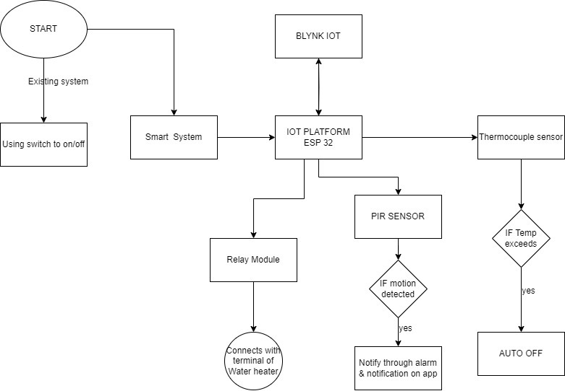**Figure 2**

**3.4 OUTPUT**

**CIRCUIT DIAGRAM**

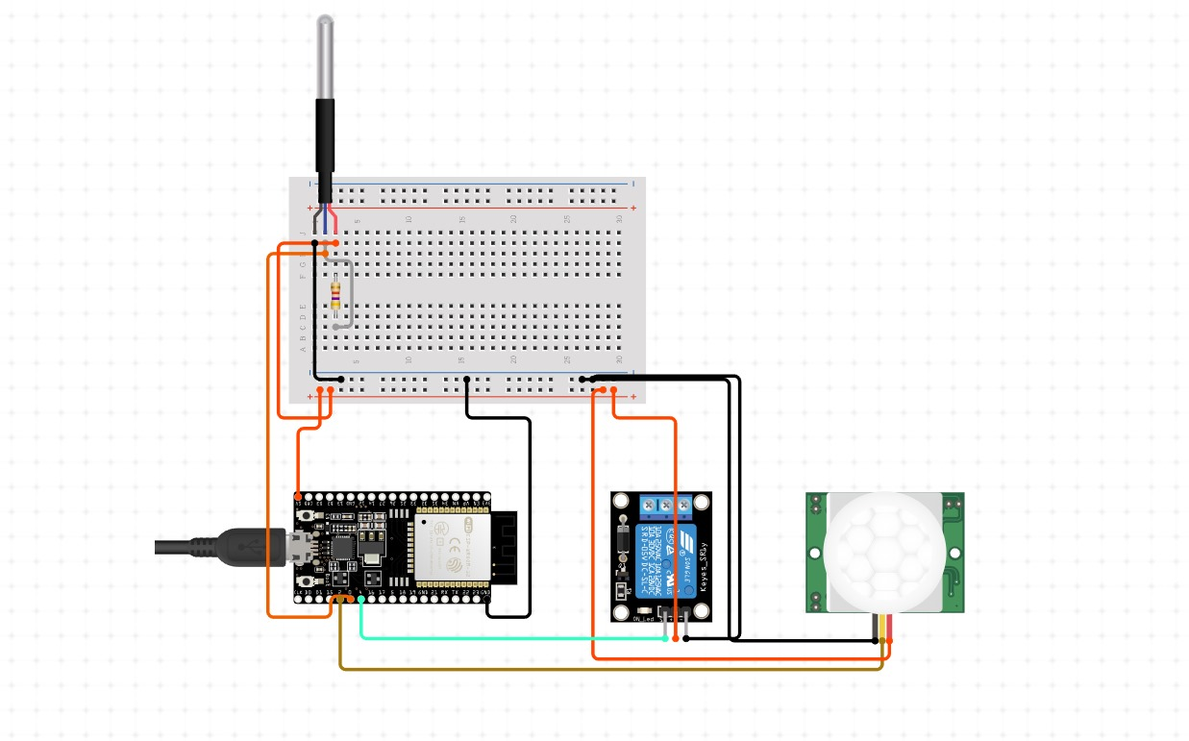

**WORKING MODEL**

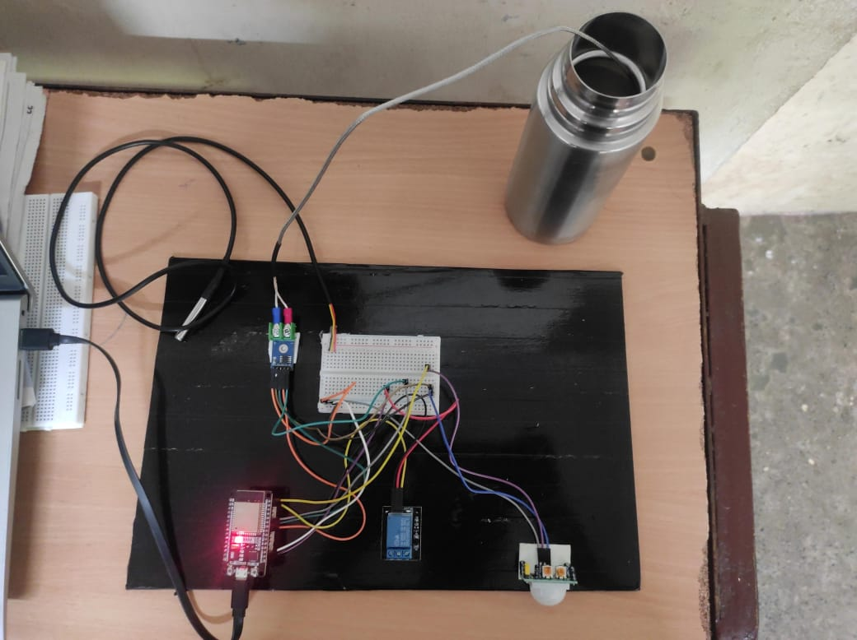

**SCREENSHOTS**

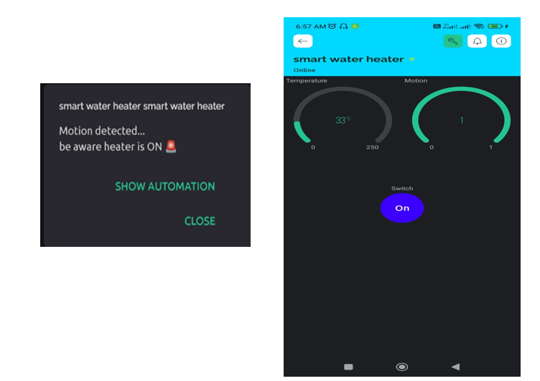

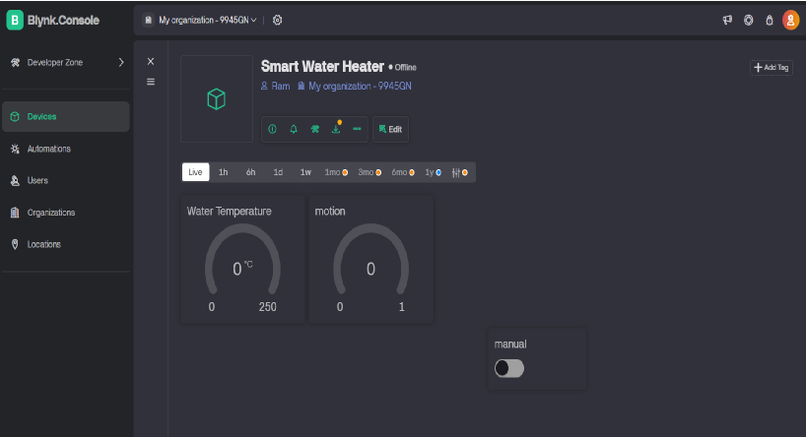

**CHAPTER 4**

**CONCLUSION AND FUTURE WORK**

In conclusion, in our IoT-based water heater project we represent a great idea in residential water heating technology, offering optimal levels of efficiency, convenience, and sustainability. By providing the power of internet connectivity,using advanced sensors, and applying intelligent algorithms, this innovative system allows the users to remotely monitor and provide control of their water heaters, optimize the energy used by users, and which enhances the safety through features like predictive heating control, demand response, and real-time data analysis. With a focus on customization, integration, and sustainability, our project covers not only the way we heat water but also sets a precedent for smart appliances, interconnected homes of the future, where comfort, efficiency, and environmental responsibility converge seamlessly.

For future enhancements of the IoT-based water heater project, we are integrating machine learning algorithms which could further refine predictive heating control, enabling the system to adapt to users' needs which are evolving the preferences and behaviors of the users dynamically. Developed integration with resources that have renewable energy, such as solar panels or heat pumps can be used to optimize energy usage and reduce the need of users to depend on power grids, providing greater sustainability. Additionally, implementation of the blockchain technology for secure, centralized data storage and transactions could provide privacy and security while enabling one-to-one energy trading between homeowners. Moreover, we can explore the potential for advanced sensors and artificial intelligence to detect and mitigate water leaks or malfunctions in real-time would further enhance safety and minimize water wastage. Overall, these enhancements would drive the project towards greater efficiency, resilience, and user-centric innovation in the evolving landscape of smart home technology.

**APPENDIX I**

#define BLYNK_TEMPLATE_ID "TMPL3wJgpnzjw"

#define BLYNK_TEMPLATE_NAME "smart water heater"

#define BLYNK_AUTH_TOKEN "dSVIf5Bj4DOpx4mvARmcrkd6KqZI1dGF" // Replace with your Blynk Auth Token

#include <WiFi.h>

#include <BlynkSimpleEsp32.h>

#include <MAX6675.h>

// Blynk credentials

char auth[] = BLYNK_AUTH_TOKEN;

char ssid[] = "_.Ram"; // Replace with your WiFi SSID

char pass[] = "Rengalaksham76"; // Replace with your WiFi password

// Pins for MAX6675

int thermoSO = 19;

int thermoCS = 5;

int thermoSCK = 18;

MAX6675 thermocouple(thermoSCK, thermoCS, thermoSO);

// Pin for PIR Sensor

#define PIR_PIN 23

// Pin for Relay

#define RELAY_PIN 22

// Virtual Pins

#define VIRTUAL_PIN_TEMP V1

#define VIRTUAL_PIN_PIR V2

#define VIRTUAL_PIN_MANUAL V3 // Virtual pin for manual control

// Variables

bool pirState = false;

bool previousPirState = false;

bool heaterState = false;

bool previousHeaterState = false;

const double TEMP_THRESHOLD = 50.0; // Temperature threshold in Celsius

// Blynk Write function for manual control

BLYNK_WRITE(VIRTUAL_PIN_MANUAL) {

bool manualControl = param.asInt();

if (manualControl) {

digitalWrite(RELAY_PIN, HIGH); // Turn on the heater

heaterState = true;

Blynk.virtualWrite(VIRTUAL_PIN_PIR, 1); // Indicate heater is on

} else {

digitalWrite(RELAY_PIN, LOW); // Turn off the heater

heaterState = false;

Blynk.virtualWrite(VIRTUAL_PIN_PIR, 0); // Indicate heater is off

}

}

void setup() {

// Initialize Serial Monitor

Serial.begin(115200);

// Initialize Blynk

Blynk.begin(auth, ssid, pass);

// Initialize GPIO

pinMode(PIR_PIN, INPUT);

pinMode(RELAY_PIN, OUTPUT);

digitalWrite(RELAY_PIN, LOW); // Ensure the relay is off initially

// Allow MAX6675 to stabilize

delay(500);

}

void loop() {

// Run Blynk

Blynk.run();

// Read Temperature

double celsius = thermocouple.readCelsius();

Serial.print("C = ");

Serial.println(celsius);

Blynk.virtualWrite(VIRTUAL_PIN_TEMP, celsius);

// Check if temperature exceeds threshold

if (celsius > TEMP_THRESHOLD) {

Blynk.logEvent("temp_exceeded", String("Temperature exceeded: ") + celsius + "°C");

digitalWrite(RELAY_PIN, LOW); // Turn off the heater

heaterState = false;

Blynk.virtualWrite(VIRTUAL_PIN_MANUAL, 0); // Update the app to show heater is off

}

// Read PIR Sensor

pirState = digitalRead(PIR_PIN);

Serial.print("PIR State: ");

Serial.println(pirState);

Blynk.virtualWrite(VIRTUAL_PIN_PIR, pirState);

// Notify if motion is detected when the heater is on

if (pirState && heaterState && !previousPirState) {

Blynk.logEvent("motion_detected", "Motion detected near the heater!");

}

previousPirState = pirState;

// Notify if the heater state changes

if (heaterState != previousHeaterState) {

if (heaterState) {

Blynk.logEvent("heater_on", "Heater turned ON");

} else {

Blynk.logEvent("heater_off", "Heater turned OFF");

}

previousHeaterState = heaterState;

}

// Delay between readings

delay(10000);

}

**REFERENCE**

[1] Kalamani, M., G. Sanjay, S. V. Sanjumeena, B. Saravanan, and Amar Prakash Mahajan. "Automation of heat pump water heater for commercial applications." *Materials Today: Proceedings* 62 (2022): 2287-2290.

[2] Benghanem, M., A. Mellit, and M. Emad. "IoT-based performance analysis of hybrid solar heater-double slope solar still." *Water Supply* 22, no. 3 (2022): 3027-3043.

[3]Sripriya, T., B. Muthuraj, D. Sateesh Kumar, V. Venkatesh, Badireddy Satya Sridevi, Munaga Masthan Siva Krishna, K. Rajan, and Abdi Diriba. "Deep Learning-Based Smart Hybrid Solar Water Heater Erection Model to Extract Maximum Energy." *International Journal of Photoenergy* 2022 (2022).

[4] Shen, Gulai, Zachary E. Lee, Ali Amadeh, and K. Max Zhang. "A data-driven electric water heater scheduling and control system." *Energy and Buildings* 242 (2021): 110924.

[5]Morse, Hanaa F., Maha S. AlGhamdi, Hussah M. Almusaied, Shouq A. Alsubaie, Dalal M. Almarri, Manal A. Alqahtani, Rasha A. Alqahtani, Rania A. Tabeidi, and Taghreed Balharith. "The Smart Heater Based on Internet of Things." In *The International Conference on Artificial Intelligence and Computer Vision*, pp. 145-153. Cham: Springer International Publishing, 2021.

[6] Chandrasekaran, Gokul, Neelam Sanjeev Kumar, Gowrishankar V, Neeraj Priyadarshi, and Baseem Khan. "IoT enabled smart solar water heater system using real time ThingSpeak IoT platform." *IET Renewable Power Generation* (2023).

[7]Chandla Ellis, R., D. Dharshini, and M. Yashwanthi. "An IoT based system for improving the solar water heater." *Mathematical Statistician and Engineering Applications* 71, no. 4 (2022): 5840-5853.

[8] Cardona, M., Victor Hugo Romo, Sebastián Gutiérrez, Pedro Manuel Rodrigo, Hiram Ponce, and Raghvendra Kumar. "Wireless temperature monitoring system through IoT for domestic solar water heaters." In *2019 IEEE 39th Central America and Panama Convention (CONCAPAN XXXIX)*, pp. 1-4. IEEE, 2019.

[9]Susanti, Hera, Afrizal Abdi Musyafiq, Hendi Purnata, Novita Asma Ilahi, and Saepul Rahmat. "Automated Water Heating Management with Internet of Things." *Journal of Telecommunication Network (Jurnal Jaringan Telekomunikasi)* 13, no. 2 (2023): 128-134.

[10] Khairunnas, Muhammad Dio, Endro Ariyanto, and Sidik Prabowo. "Design and implementation of smart bath water heater using Arduino." In *2018 6th International Conference on Information and Communication Technology (ICoICT)*, pp. 184-188. IEEE, 2018.

[11]Hasan, Mohammad Kamrul, Musse Mohamud Ahmed, Bishwajeet Pandey, Hardik Gohel, Shayla Islam, and Izzul Fitrie Khalid. "Internet of Things-based smart electricity monitoring and control system using usage data." *Wireless Communications and Mobile Computing* 2021 (2021): 1-16.